§

AREDN Setup  
V2

Andreas Spiess, HB9BLA (hb9bla@gmail.com)  
  
11.7.2024

Content

Preparation 3

Yealink Phones 5

Flash the Phone 5

Phone Setup 6

Standard phone book 9

Backup phonebook (with full mesh address) 9

Flash Mikrotik devices 12

Preparations 12

Change PC to a fixed IP address 13

Flash elf file to target device 15

Flash AREDN Firmware 17

Configure AREDN 18

Make your telephone visible to the network 19

Set up a tunnel to the AREDN network 20

Phonebook 23

Principle of operation 23

Installation 24

Upgrade from a V1 version of the phone book 24

Installation of new phonebook 25

Troubleshooting (Files to check): 26

Config file 26

Phonebook 27

Using a PBX in parallel 27

Attachments 28

Google sheets replication 28

# Preparation

You can find all relevant files on GitHub (<https://github.com/dhamstack/AREDNstack> )

Press "code" and "Download ZIP". The file is quite big (>500M):

Ein Bild, das Text, Screenshot, Zahl, Schrift enthält.

Extract the ZIP file:

Ein Bild, das Text, Screenshot, Software, Computersymbol enthält.

Now you should have all needed files in your Downloads/AREDNstack-main/ folder:

Ein Bild, das Text, Screenshot, Zahl, Schrift enthält.

In the Firmware Repo folder, you will find files for the current version of AREDN:

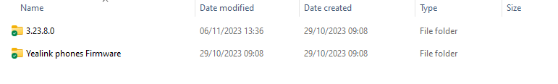

You also find firmware for our typical phones to flash with "free" firmware (not connected to a provider).

Ein Bild, das Text, Screenshot, Schrift, Zahl enthält.

# Yealink Phones

## Flash the Phone

1. Download and unzip tftpd64.464.zip (the "run", not the setup version) (<https://bitbucket.org/phjounin/tftpd64/downloads/> )
2. Disconnect your computer from Wi-Fi and Ethernet and set a fixed IP address (e.g., 192.168.0.4)
3. Start tftp64.exe
4. Click the browse button to locate the TFTP root directory   
   Ein Bild, das Text, Screenshot, Schrift, Zahl enthält.

   Automatisch generierte Beschreibung  
   You should be able to see the files your phone will request during flashing.
5. Select the local IP address from the "Server Interface" drop-down menu.  
   Ein Bild, das Text enthält.

   Automatisch generierte Beschreibung  
   If you do not find your fixed IP, something is wrong, and you must start over.
6. Connect the SIP phone to the PC with an Ethernet cable. Use the “Internet” socket on the telephone. Use the “Internet” socket on the telephone
7. Power the Yealink with the speaker button pressed until you see a selection(TFTP or USB) or the below screen. Press 1 for TFTP if presented.
8. Fill in the fields as shown. Make sure you use a free IP address for the telephone (e.g., 192.168.0.230 ):

IP Addr: 192.168.0.230

Netmask: 255.255.255.0  
Gateway: 192.168.0.1  
TFTP IP: 192.168.0.4

1. Hit enter (OK) and wait. The display on the phone shows “Start Updating…”. You should see in the tftp64 window on the PC that the phone fetches files from your computer.
2. As soon as all files have been read from the PC, the phone will automatically restart. However, this can take a few minutes. As soon as the phone displays a display again (e.g. “Obtaining IP address…” carry out the following step
3. Hold down the OK button until the message “Reset to factory setting?” appears. Confirm this message with the »OK« key. The message “Resetting to factory setting, please wait” appears, and then the welcome screen appears.
4. Remove power from the phone
5. The flashing of the SIP phone is now finished, and the phone is now ready for settings for the AREDN mesh.
6. Connect the phone to your hap router (port 2-4) and to power. After booting, go to the “About” menu on your phone to find the IP address.

Now, you are ready for the next step.

## Phone Setup

With the firmware for your phone, you also find a file with the extension .CFG.

Ein Bild, das Text, Schrift, Zahl, Reihe enthält.

Edit this file and replace XXXXXX with the phone number you want for your phone. You can change the language by placing the # in the right place.

Ein Bild, das Text, Screenshot, Zahl, Schrift enthält.

Replace the display.name if you want. Save it. SOP means Swiss Official Phonebook, BTW.

Go to a browser, type the IP address of your phone into the address, and login using admin/admin.

Ein Bild, das Text, Screenshot, Schrift, Zahl enthält.

Change your password if you want.

Now go to Settings🡪 Configuration.

Ein Bild, das Text, Screenshot, Software, Webseite enthält.

Go to "Import CFG configuration file and browse to the Txx.cfg file you edited before. Hit "Import" and wait till the phone rebooted.

After reboot, go to Directory 🡪 Remote Phone Book and check if the remote phone book screen looks like that:

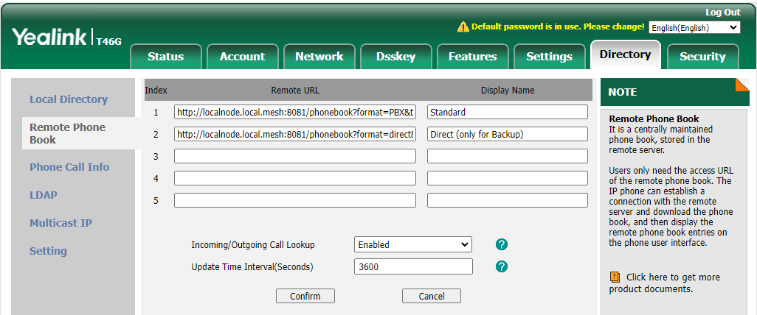

The two phonebooks for copy-paste:

### Standard phone book

<http://localnode.local.mesh:8081/phonebook?format=PBX&target=generic&ia=true>

This file stores the telephone number. The PBX knows this number, and the new SIP server automatically creates the mesh address for direct calling.

### Backup phonebook (with full mesh address)

If you want to store the full mesh address as a backup on your phone, you can add the second line. It is not needed.

<http://localnode.local.mesh:8081/phonebook?format=direct&target=generic&ia=true>

Go to Directory 🡪 Setting and fill the fields like that:

Ein Bild, das Text, Screenshot, Software, Computersymbol enthält.

Confirm

Now, you should see a small phone in your phone's display that shows it is ready for the AREDN network. You should also see a "direct" and "PBX" folder if you press the "Directory" button on your phone.

Check if you phone is enabled for IP telephony:

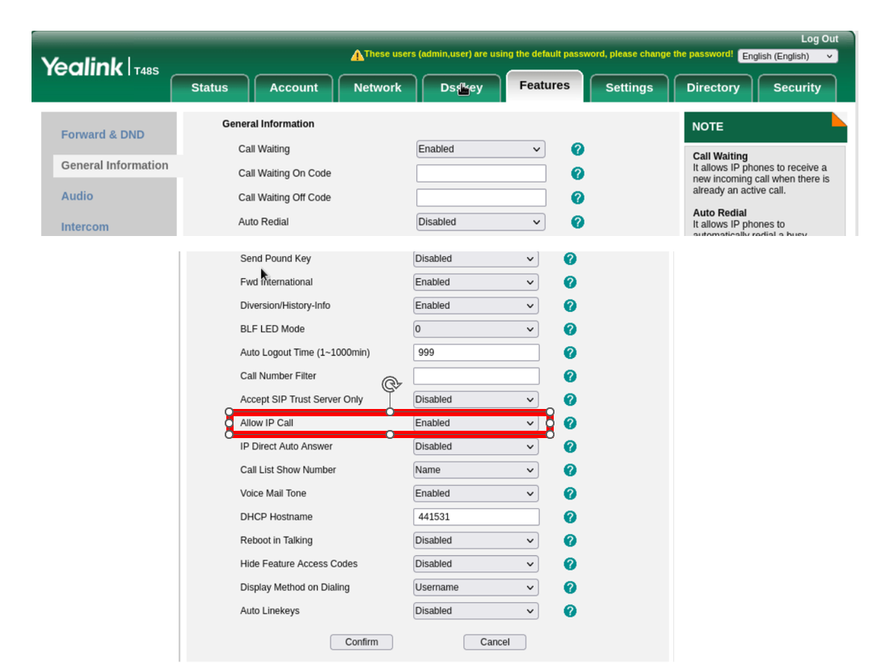

If your Mikrotik router already works with AREDN, you can skip the next step and install the phonebook and SIPserver. If not, continue with the next chapter.

# Flash Mikrotik devices

## Preparations

The small Mikrotik hap ac-lite box or square Access PointSXTsq (AP) will hereafter be referred to as "target devices." Green are the notes for the AP.

Download the newest version for the hap lite from this address:

<https://downloads.arednmesh.org/afs/www/?version=3.24.6.0&target=ath79%2Fmikrotik&id=mikrotik_routerboard-952ui-5ac2nd> :

*Rename the kernel bin file file to rb.elf.*

*For all other devices go to* [*Installing AREDN® Firmware — AREDN Documentation latest documentation (arednmesh.org)*](https://docs.arednmesh.org/en/latest/arednGettingStarted/installing_firmware.html) *to get instructions on how to find and rename the files.*

Download the Tiny PXE Server ([*http://erwan.labalec.fr/tinypxeserver/pxesrv.zip*](http://erwan.labalec.fr/tinypxeserver/pxesrv.zip) ) and unpack it to a convenient directory.

Go to the Tiny PXE Server directory:

Ein Bild, das Text, Screenshot, Software, Multimedia-Software enthält.

And copy the rb.elf file from before to the «Files» folder of the PXE server (overwrite if necessary).

Connect your target device to a switch as shown below (connect the LAN cable to the “internet” port of the hap router):

Ein Bild, das Computer, Text, Elektronik, computer enthält.

Deactivate Wi-Fi on the PC and supply power to the dumb switch.

## Change PC to a fixed IP address

Type

ncpa.cpl

into Windows search  
  
Ein Bild, das Text, Screenshot, Software, Multimedia-Software enthält.

Select "Ethernet"  
Ein Bild, das Text enthält.

Select «Properties»:  
Ein Bild, das Text, Screenshot, Software, Betriebssystem enthält.

Select IPV4:  
Ein Bild, das Text enthält.

Input IP address 192.168.1.50:  
Ein Bild, das Text enthält.

Press OK and Close

## Flash elf file to target device

Check if the ethernet cable is connected to **port 1** of the hap router (labeled with Internet), supply the router with power and wait until the top red LED is off and the green LED above with the number 1 flickers. Possibly Windows detects a new network. Then a larger blue window will appear on the right side of the screen, mentioning the new network. Confirm with OK. The whole thing takes about 3 minutes.

Do the same with the AP. Use the PoE injector (Y-cable) for the power supply. The power supply unit of the router also works here (both are 24V).

Start Tiny PXE Server (double click on the pxesrv.exe file in the «pxesrv» directory). You might get this warning:

Ein Bild, das Text, Screenshot, Schrift enthält.
Ein Bild, das Text enthält.

Press «More info» and let the program run.

Now pull the power of the target device.

In the Tiny PXE Server window, select the IP address entered on the Ethernet adapter from the drop-down box (192.168.1.50). If this IP address cannot be selected, close the Tiny PXE Server and start it again. If it still doesn't work, check the IP4 adapter settings and start again.

Find and select rb.elf in the «Boot File» section. This file can be found in the «…\pxesrv\files» folder.

Uncheck «Filename if user class...». No additional settings are necessary.

Ein Bild, das Text, Screenshot, Zahl, Schrift enthält.

Now switch the Tiny PXE Server to «Online» in the upper right corner.

Then press the reset button in the target device with a pointed object (e.g., paper clip or toothpick) and then plug in the power cable to the target device. The USR LED will be on, flashing, and off (5 seconds each). Check the log window. Immediately after the bottom line says "Do ReadFile:rb.elf ………" release the reset button and switch the Tiny PXE Server to "Offline." This procedure takes about 20 seconds. The target device now boots with the AREDN firmware.

Don't keep the reset button pressed for too long, or you'll have to start over!

Keep the device powered, otherwise you have to start over!

Switch the Ethernet adapter on the PC back to the "automatic IP address." Plug the Ethernet cable into **port 2** on your router. After about two minutes, the process should be finished.

With the AP, the Ethernet cable remains in the only socket. The rest is the same

*Optional: Check with ipconfig whether our PC has received «local.mesh».*

## Flash AREDN Firmware

Now open a browser and enter 192.168.1.1. The picture should look something like this.

Ein Bild, das Text, Schrift, Screenshot, Design enthält.

If not, back to start

Now let's install the actual firmware on the target device. Click on setup and enter username/password:

User: root

Password: hsmm

The following view appears:

Ein Bild, das Text, Screenshot, Schrift enthält.

Now uncheck “Keep Existing Configuration Settings” and select the firmware.

Names of the files as discussed above (file names similar to «aredn-3.23.8.0-ath79-mikrotik-mikrotik_routerboard-952ui-5ac2nd-squashfs-sysupgrade.bin»):

Click «Upload.» The actual firmware is now loaded into the target device. The target device boots several times, and it takes about 10 minutes.

Once the software has been installed, Windows can again bring up a blue window on the right side of the screen.

## Configure AREDN

Open the browser and enter the following line http://localnode.local.mesh:8080 (or 192.168.1.1)

If there is no answer, the process is not yet complete. Try again and again. If you still can't connect after 15 minutes, go back and start again.

The necessary settings can be made under «Basic Setup.»

User: root

Password: hsmm

Ein Bild, das Text, Screenshot, Software, Zahl enthält.

* A new password must be set before the first save. Otherwise, the changes will not be saved
* For the node name, please enter your call sign as shown above.

Only on the hap router:

* Also, enter your call sign for SSID, and set a password. Remember this SSID name and the password, you will need it later to connect the WLAN of the hap router. Tick «LAN Access Point»
* Fill in «Optional Settings»

Then, reboot the target device.

## Make your telephone visible to the network

Telephones have to be visible to others:

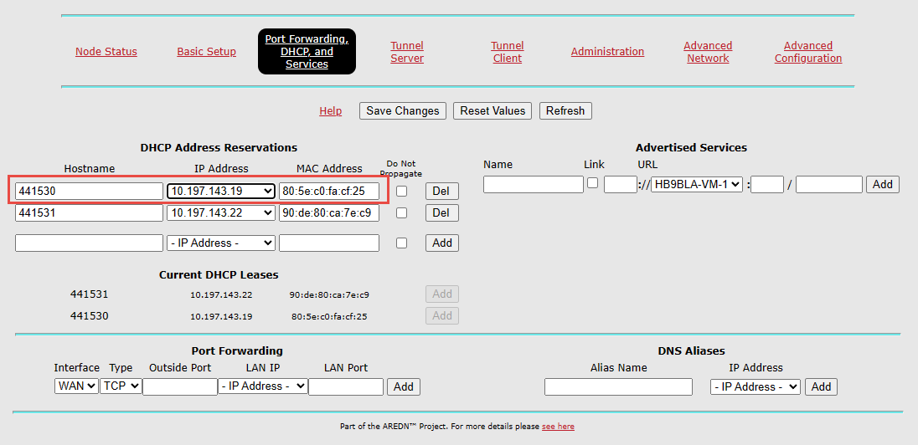

You get the telephone number from HB9JAT, HB9BND, or HB9BLA. MAC address is found on the telephone under «information».

In the future, all telephone numbers have to add the area code.

After reboot, your telephones have to be visible in „mesh status“ near your station:

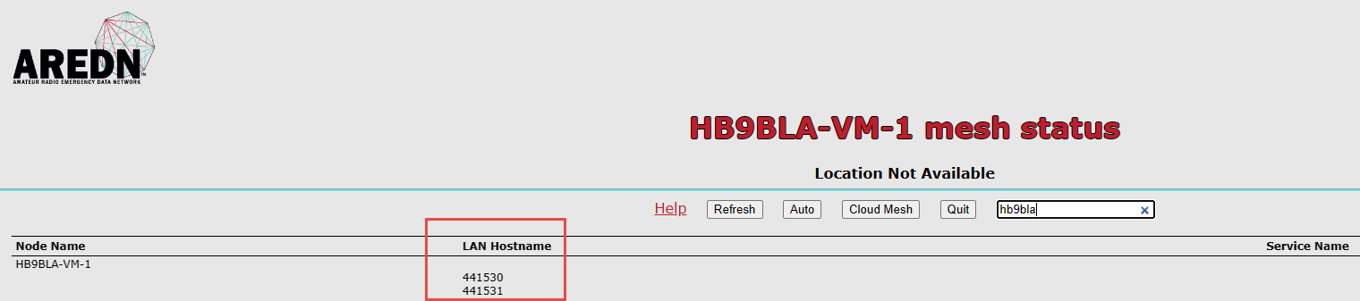

## Set up a tunnel to the AREDN network

(only necessary if you connect via an Internet tunnel)

This chapter only applies to the hap router.

Connect port 1 (Internet) to the Internet.

From now on, you can access the router via Wi-Fi from your PC by looking for the right WLAN and connecting your PC to the router:

Ein Bild, das Text, Screenshot, Software, Betriebssystem enthält.

You should get the tunnel data from your tunnel server responsible:

Server: his server address

PwD: The password he assigned to your tunnel

Network: The address of your tunnel

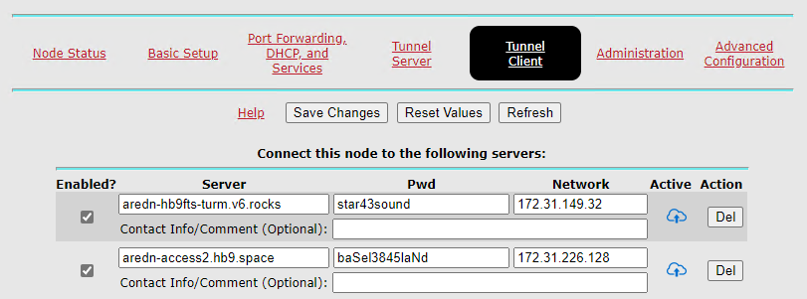

172.31.229.148

hisServer.com

Tick «enable» and press «Save changes.»

Your tunnel should be active after a short time (blue cloud with an arrow).

You are now connected to the AREDN network. Go to «Node-Status» / «Mesh Status» and enjoy the success.

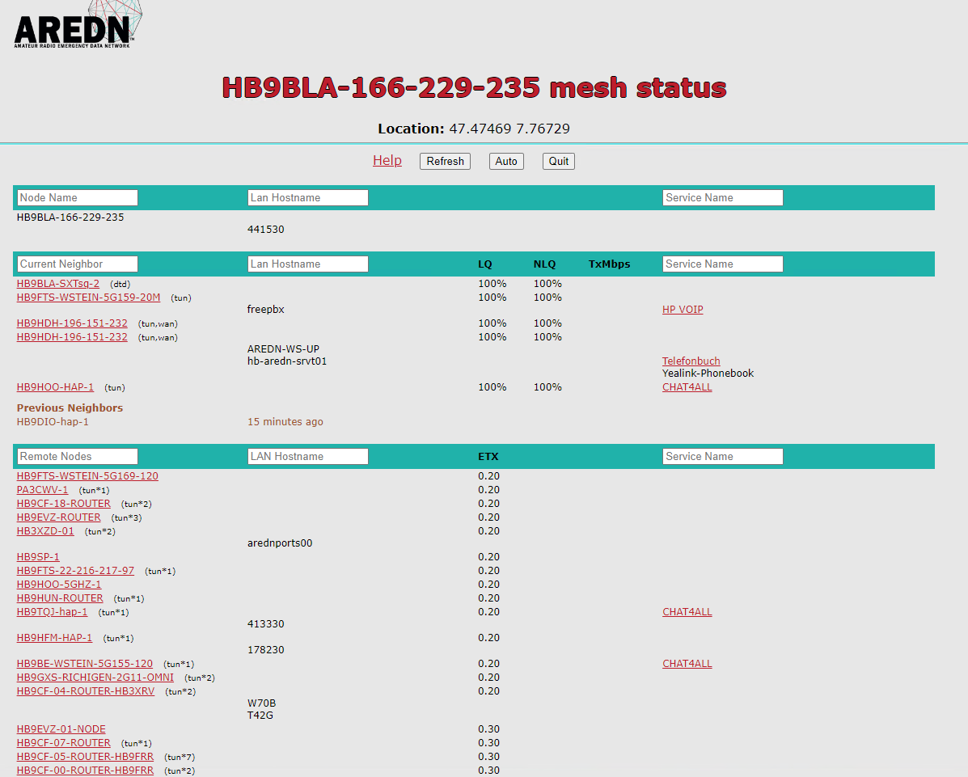

Note the LAN address:

Ein Bild, das Text, Screenshot, Schrift, Zahl enthält.

# Phonebook

This project aims to create a common Global AREDN telephone network. Local telephone books are distributed to all participating AREDN phones connected to the SwissDigitalNetwork or, via Supernodes, worldwide. By storing the latest version on each router, we can ensure that, during an emergency, we have no single point of failure. Each phone can call all reachable phones without a (central) PBX.

## Principle of operation

You can skip this chapter and go to "Installation" if you are not interested in how the telephone book works.

AREDN is a mesh network, and we do not want to create a single point of failure. This is why the telephones get their phonebook files from the hap router they are connected to. So, a phone gets its phonebook as long as its router works.

We use direct calling instead of a PBX to avoid a single point of failure for communication, reduce the latency time, and reduce the overload of single mesh segments. The address used for this case is an FQDN like [178230@178230.local.mesh](mailto:178230@178230.local.mesh). If you want or need to operate a PBX, the address is just a phone number like 178230. In Switzerland, we use the city's zip code of the HAM plus a two-digit number in the range of 30-70. Lower numbers are reserved for official use.

The "Official" Swiss AREDN phonebook (SOP) is on Google: <https://docs.google.com/spreadsheets/d/1g33BHSXMC8T4Cmfz_Zq-XxtPP17dtEBexF2i4KKe_Mc/edit?usp=sharing>. You can create a comment to add or change something or notify one of the administrators to do it for you.

Other countries will have their own telephone book (one per international area code). The maximum length of a local phone number is 7.

xxx-yyyyyyy

xxx: 3-digit area code

yyyyyyy: 7-digit local number (in Switzerland, currently only 6 are used)

Examples:

A global number in Switzerland starts with 041 (e.g. 041441530). For your comfort, you only have to dial the short number (in Switzerland, 441530). The SIP server on your router automatically adds 041 (it is defined in the config file).

Other nations use their international area code. It must have three digits. So, the US has 001 and Lichtenstein 423.

Currently, we support Yealink telephones, and Cisco phones are in the test.

At power-up and every hour, the telephones used for AREDN automatically load phonebooks from the connected router. The file format used for that process is XML.

How is the information transferred from the Google Sheets to your hap router? The first step is to copy the .csv version of the sheet from Google to a web server in the AREDN mesh. If Google is down, we could still edit this .csv file manually. This transfer is done every hour. You find more info in attachement.

## Installation

If you are already on the newest AREDN version and have no phonebook installed, you can omit the de-installation step and proceed to the phonebook installation.

## Upgrade from a V1 version of the phone book

First, remove the Phonebook and the SIPsever in ARDN administration:

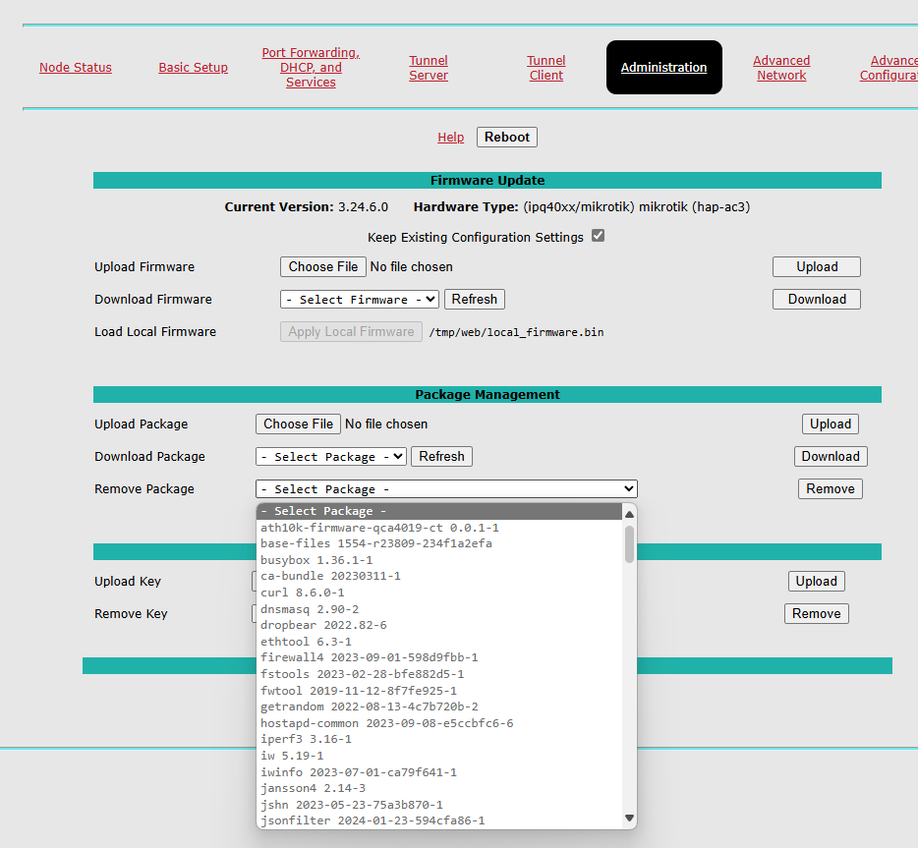

Then remove libstdcpp6. Most probably, it will not be possible from the same menu. So you have to use a terminal software like MobaXterm or Putty to SSH into your router (port: 2222). Remove libstdcpp6 with the following command:

opkg remove --force-removal-of-essential-packages libstdcpp6

Now, connect your router to your home network (use port 1). Go to “Administration” and upgrade your router software to the newest version. Connected to the internet, you can download the new version and install it (it takes a while till the versions are displayed):

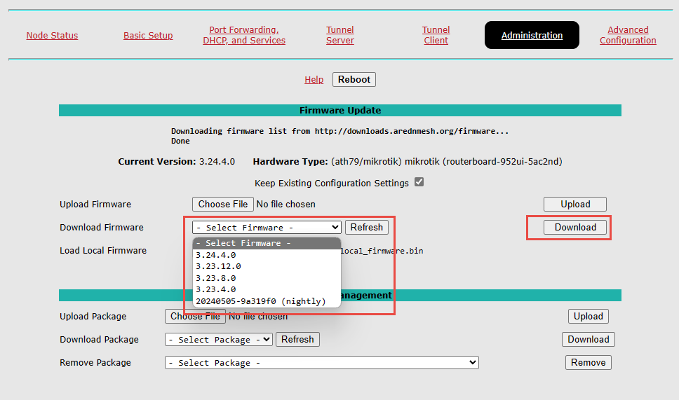

Leave “keep existing configuration” ticked

### Installation of new phonebook

Go to the releases page and open “Assets”:

https://github.com/arednch/packages/releases

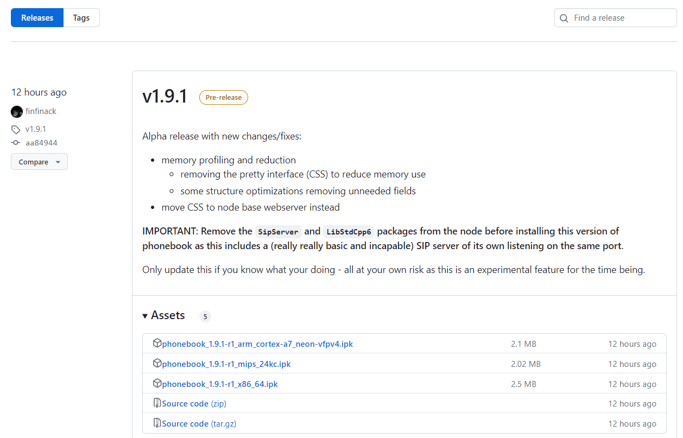

Download the respective ipk file (mips-24kc for the small hap lite and arm-cortex for the hap3). The ipk file includes the phonebook, the SIP server, and all libraries.

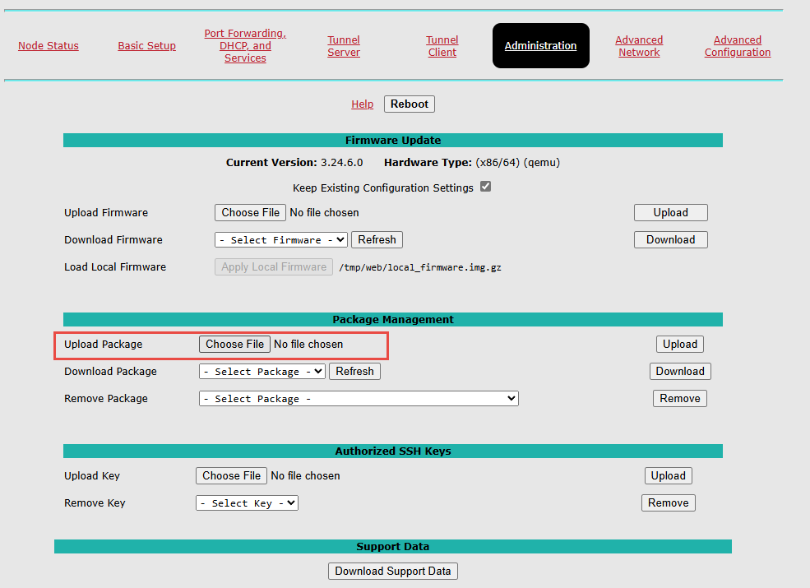

Chose the correct “phonebook” file and “upload it. This starts its installation.

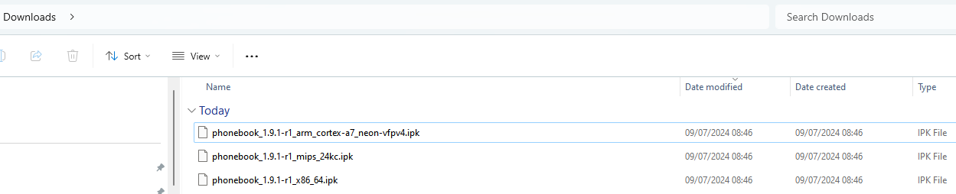

Now, you can connect your router to your AREDN network. After rebooting, the attached phone should connect to the sip server, and you should be able to download the phonebook with all numbers.

## Troubleshooting (Files to check):

### Config file

You can influence the behavior of your phonebook software by changing parameters with the command

vi /etc/phonebook.conf

Important are these two parts:

**formats: Comma separated list of formats to export.**

Default:

"formats": [

"direct",

"pbx"

],

- Supported: "pbx,direct,combined"

**targets: Comma-separated list of targets to export.**

Default:

"targets": [

"generic"

],

- Supported: generic,yealink,cisco,snom

### Phonebook

[localnode.local.mesh:8081/phonebook?format=direct&target=generic&ia](http://localnode.local.mesh:8081/phonebook?format=direct&target=generic&ia)=true

should show you the actual phonebook

User: aredn  
Pwd: arednsecret

<localnode.local.mesh:8081/reload>

should load the actual telephone book from the AREDN server (not from Google sheet)

## Using a PBX in parallel

If you want to use a PBX, you must add a second account with the respective information given to you by the PBX operator.

# Attachments

## Google sheets replication

Create a file:

vi /etc/cron.hourly/load_phonebook_from_google

and insert:

#!/bin/sh

curl -L “https://docs.google.com/spreadsheets/d/e/2PACX-1vTZw1cwlV6pdFETvC-JnI0gPwKRwR0rBUc2XqX9V3LV1NfrB0zvhhWKmrYVS1eippbs91lMLfkeXj6-/pub?gid=0&single=true&output=csv” -o /www/filerepo/Phonebook/AREDN_PhonebookV2.csv

curl -L "https://docs.google.com/spreadsheets/d/e/2PACX-1vTZw1cwlV6pdFETvC-JnI0gPwKRwR0rBUc2XqX9V3LV1NfrB0zvhhWKmrYVS1eippbs91lMLfkeXj6-/pub?gid=0&single=true&output=csv" -o /www/filerepo/Phonebook/AREDN_Phonebook.csv

curl -L “https://docs.google.com/spreadsheets/d/e/2PACX-1vTZw1cwlV6pdFETvC-JnI0gPwKRwR0rBUc2XqX9V3LV1NfrB0zvhhWKmrYVS1eippbs91lMLfkeXj6-/pub?gid=208565882&single=true&output=csv

Now your router should load the newest telephone book from the path defined in

vi /etc/phonebook.conf

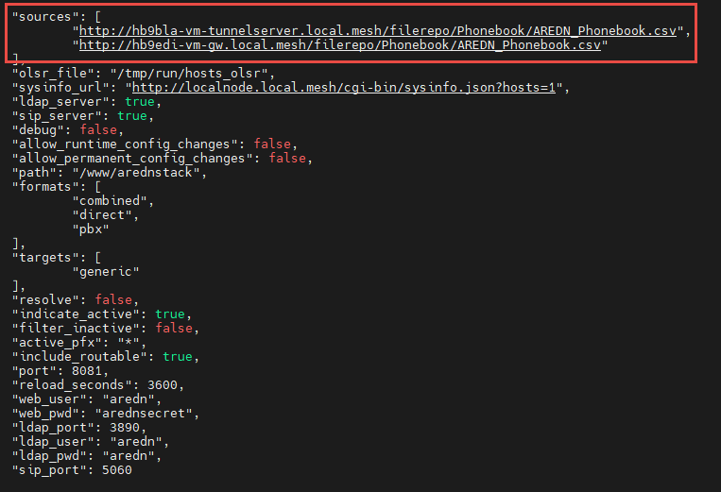

The second path is for backup.